Saint Lucie County Property Appraiser CAMA Summary Data (June 2025)
The PropertyID is the field that ties the data files to a property within the Property Appraiser’s CAMA system. Each file is formatted in a comma separated values file with the first row containing the column headers.

The PropertyIndex file is used to assist the users with converting between the property’s ParcelID and the internal PropertyID.
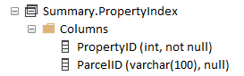

The PropertyIdentification file contains general information regarding the property.
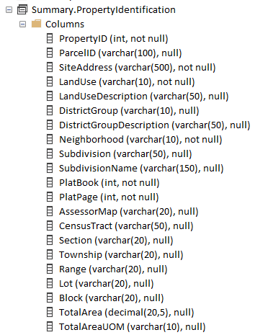
The PropertyOwnership file contains information about the primary owners and their mailing address.
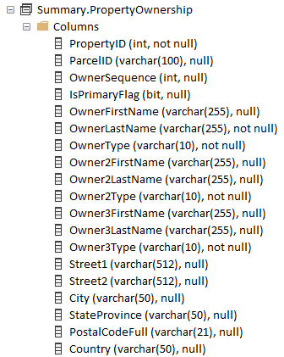

The LegalDescription file contains the legal information regarding a property.
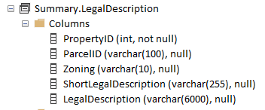

The SiteLocation file contains the location information regarding the property site location.
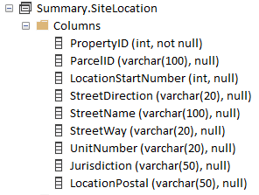

The Assessment file contains the various values associated with a property. This data changes infrequently throughout the year as these values are only calculated at key times of the assessment year (e.g. TRIM, Final Value, and Post VAB Hearings).
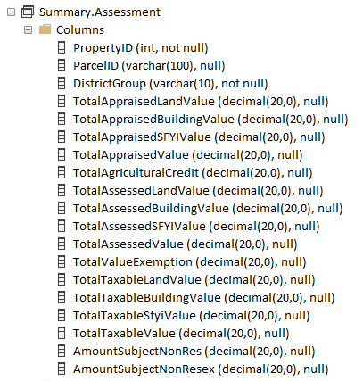

The BuildingBasics, BuildingExterior, BuildingInterior, and BuildingSubAreas files contain information related to the buildings associated with the property.
Note: BuildingID will connect the building files together and that there are blank building records in the BuildingBasics, BuildingExterior, and BuildingInterior files as the CAMA system creates these empty records for non-improved properties.
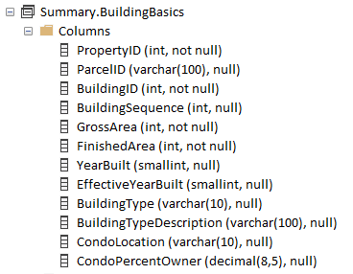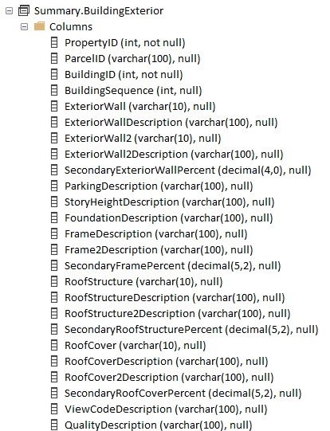
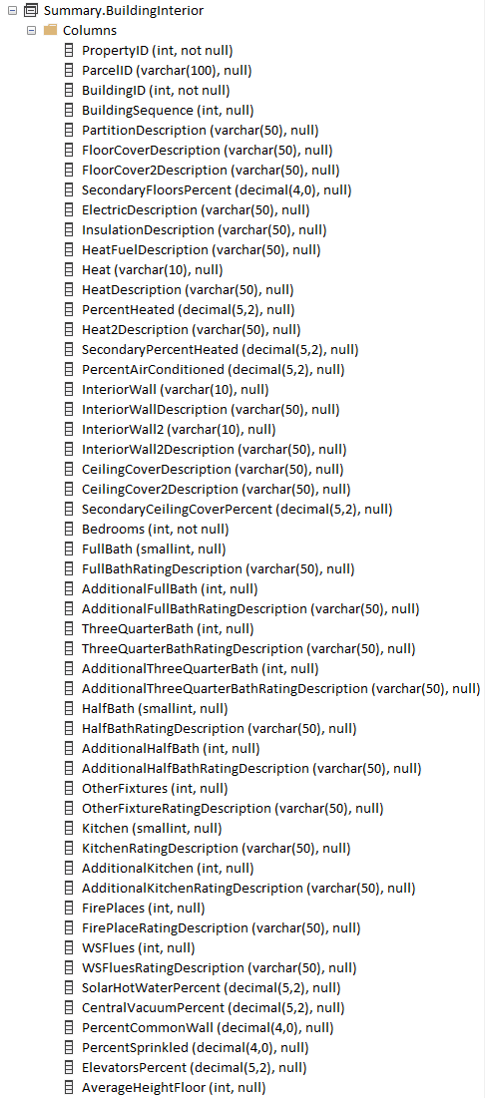
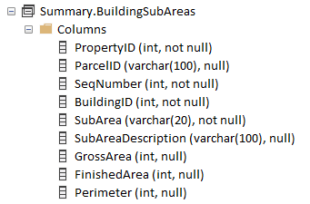

The Exemptions file contains records of the exemptions associated with the properties.
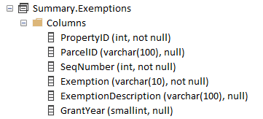

The ParcelDistricts file is for taxing authorities to utilize.
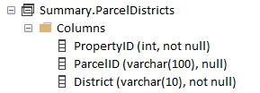

The OtherAssessments file contains records of non-ad valorem assessments on file with the Property Appraiser.
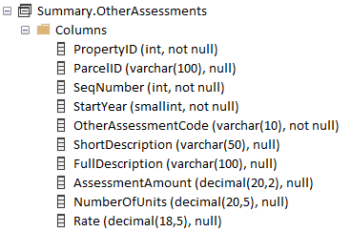

The SFYI file contains Special Feature Yard Item information associated with the property.
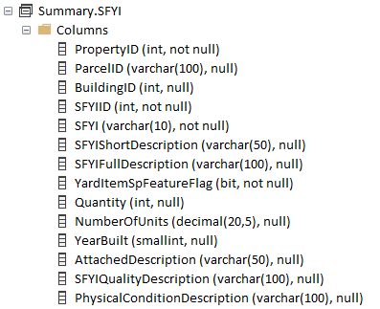

The Transactions file contains the sales information associated with each property.
